**CMSC203 Assignment 6 Implementation**

Class: CMSC203 CRN 32295

Program: Assignment #6

Instructor: Ahmed Tarek

Summary of Description:

The BevShop offers 3 types of beverages: Coffee, Alcoholic and Smoothie. Beverages can be ordered in 3 different sizes: Small, medium and large. All the beverage types have a base price. In addition there are additional charges depending on the size and specific add-ons for each type of beverage.Integrity Pledge: I pledge that I have completed the programming assignment independently.

I have not copied the code from a student or any source.

Student’s Name: HUYNH MINH QUAN NGO

**Part 1: UML diagram:**

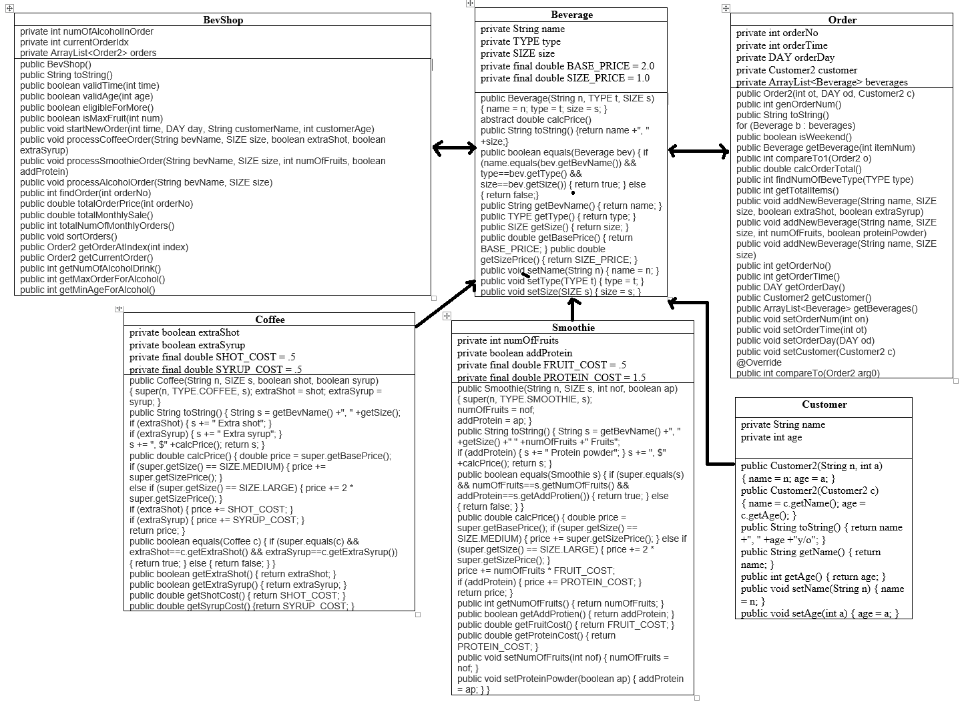

**Part 2: Screenshot related to the Project:**

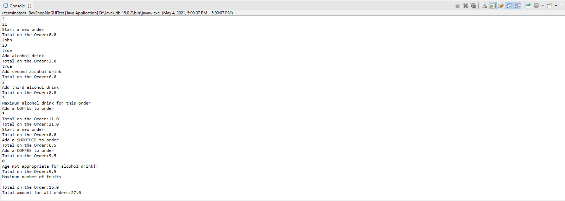

**Part 3: Learning Experience:**

Write about your Learning Experience, highlighting your lessons learned and learning experience from working on this project.

Working on this assignment based on the Pseudocode help a lot and easier to narrow down what to do. It’s take a lot of JAVA study to code for this assignment.

What have you learned?

Through this Project, I learn how to create and process orders of different types of beverages, provide information on all the orders, total amount on a specific order, monthly total number of orders, monthly sale report.

What did you struggle with?

Took a bit of time to figure out how read the files as well as passing arrays.

What would you do differently on your next project?

I would try to work around on all the provided java files for this assignment in order to alter the way to code.

What parts of this assignment were you successful with, and what parts (if any) were you not successful with?

On this project, my most successful part would be planning the pseudocode and logic. I would consider the unsuccessful part be figure out how all provided java files in order to work on the assignment.

Provide any additional resources/links/videos you used to while working on this assignment/project. N/A